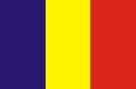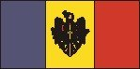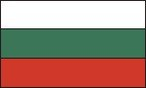

EAST-EUROPEAN COURSE ON EPILEPSY
(11-13 June 2014)
- Cheile Gradistei, Romania -

This course is supported and endorsed by ILAE-CEA and organized under the umbrella of ILAE Romania, in collaboration with Romanian Society of Pediatric Neurology (SRNP), Romanian Society of Neurology (SNR) and Romanian Foundation for Epilepsy and Neurology (RONEP) with support from Rotary OCTO.

Course directors: Dana Craiu, Stanislav Groppa, Alla Guekht

Local Organizing committee : Dana Craiu, Ioana Mindruta, Catrinel Iliescu, Laura Popescu; Sectretary : Florentina Grigore (flore.ronep@yahoo.com)

Scientific Committee: Sandor Beniczky (Denmark), Meir Bialer (Israel), Dana Craiu (RO), Helen Cross (UK), Petia Dimova (Bulgaria), Kyriakos Garganis (Greece), Stanislav Groppa (Rep Moldova), Alla Guekht (Russia), Hrvoje Hecimovic (Croatia), Hans Holthausen (Germany), Catrinel Iliescu (RO), Volodymyr Karytonov (Ukraine), Ioana Mindruta (RO), Krassimir Minkin (Bulgaria), Lorella Minotti (France), Walter van Emde Boas (Netherlands)

Course general information
The 2014 Course offers basic knowledge on epilepsy in children and adults based on interactive clinical case-discussions (participants are invited to send their cases related to the announced topics for review and selection at least 1 month before the curse at flore.ronep@yahoo.com). Lectures offered by the faculty will summarize knowledge. This course has international appeal.

Topics
Semiology related to lobe localization (F, T, P, O), EEG in epilepsy, Differential diagnosis, Imaging epilepsy, Treatment (drug therapy and basic knowledge on epilepsy surgery with cases from East-European countries).

Faculty
Sandor Beniczky (Denmark), Meir Bialer (Israel), Dana Craiu (RO), Helen Cross (UK), Petia Dimova (Bulgaria), Kyriakos Garganis (Greece), Stanislav Groppa (Rep Moldova), Alla Guekht (Russia), Hrvoje Hecimovic (Croatia), Hans Holthausen (Germany), Catrinel Iliescu (RO), Volodymyr Karytonov (Ukraine), Ioana Mindruta (RO), Krassimir Minkin (Bulgaria), Lorella Minotti (France), Walter van Emde Boas (Netherlands)

Target audience
Pediatric neurologists and adult neurologists, neurophysiologists, psychiatrists, neurosurgeons with a medium level of expertise in the area of epilepsy care (already dealing with epilepsy patients). The 2014 course aims for 60-80 participants with possibility of extending to 100 if there is request for it.

Venue 2014: Cheile Gradistei, Romania
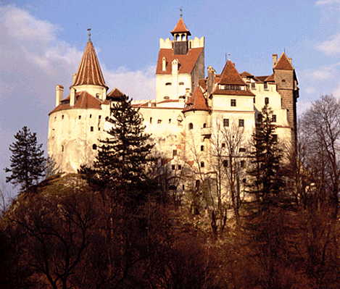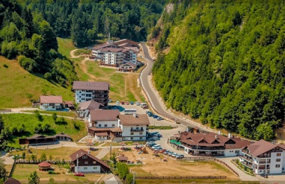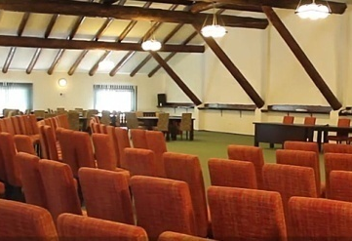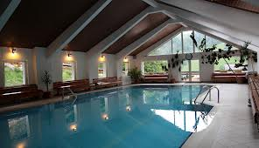
http://www.cheilegradistei.ro/resort-moeciu/index.php?page=home&lang=en
Cheile Gradistei is situated 3 hours driving from Bucharest airport (direct flights from most European cities and UK) and 2.5 hours away from Sibiu airport (directly connected to some European cities). It is situated in the middle of Romania, Transylvanian area, near Brasov city and 5 km near Bran Castle, the so called “Dracula’s Castle”.
Cheile Gradistei offers a special advantage of isolation in the middle of splendid nature creating the possibility of good interaction among participants and trainers, premises for future collaboration and friendship. Cheile Gradistei is located 5 km near Bran Castle, the so called “Dracula’s Castle”.

Transport to venue: Participant’s arrival is expected the evening before the course (June 10th). Cheile Gradistei is situated 3 hours driving from Bucharest airport (direct flights from most European cities and UK) and 2.5 hours away from Sibiu airport (directly connected to Munich). Due to distance, arrangements will be made for transportation of all participants and trainers From Bucharest to Cheile Gradistei and back within certain time limits (will be further announced).

Accommodation: The course organizers booked 80 rooms in Cheile Gradistei Complex at special prices (included in the course cost).

Cost of the whole course: 400 euro covers:
- Registration fee
- Accommodation: 4 nights in double room (2 participants/room); for single room accommodation, a difference of 20 euro/night should be paid.
- Meals (4 x breakfast + 4 x dinner + 3 x lunch)
- Social programme during course
- Materials for course

Bursaries
20 bursaries offered by CEA-ILAE are available and will cover:
- Accommodation: 4 nights in double room (2 participants/room)
- Meals (4x breakfast + 4 x dinner + 3x lunch)
- Social programme during course
- Materials for course
All bursary recipients will pay a registration fee of 100 euro.
For payment see Booking form.

Criteria for bursary application will include: 1. Participants from East-European countries (Bulgaria, Romania, Republic of Moldova, Ukraine, Russia); 2. Applicants did not receive an ILAE bursary or do not plan to ask an ILAE bursary during the year 2014. 3. Young trainees will have priority (under age 40).
Bursary applicants should send a CV and recommendation from the head of their clinic until April 25th.

Deadlines
– 25 May 2014 for final registration
- 25 April 2014 – bursary applications (results of selected bursary recipients) – 30 April 2014.

